# Investigation and Management of Pulmonary Embolism

Table of Contents

Introduction..............................................................................................................................................

Risk stratification and severity assessment ................................................................................

Definitions...................................................................................................................................

Management of High Risk PE....................................................................................................................

Management of Intermediate High Risk PE..............................................................................................

**INTRODUCTION**

* Initial risk stratification of suspected or confirmed PE, based on the presence *of haemodynamic* *instability,* is recommended to identify patients at high risk of early mortality
* A clear definition of haemodynamic instability and high-risk PE is provided
* In patients *without haemodynamic instability*, further stratification of patients with acute PE into intermediate- and low-risk categories is recommended with the use of validated score combining clinical (sPESI), imaging and laboratory PE-related prognostic factors
* A dedicated management algorithm is proposed for high-risk PE and Intermediate High Risk PE
* A MDT approach (PERT) that brings together Respiratory, Cardiology, Intensive Care, Cardiac Surgery and Interventional Radiology and Haematology is encouraged
* Advice within hours can be sought contacting authors of the guidelines via switchboard or by email.
* The model might differ in hours with OOHs where mostly the On Call Team (IR, Intensive Care, Cardiology, Resp and Cardiac Surgery) will communicate to formulate and deliver a plan
* For low risk PE and Ambulatory care see link below

[Ambulatory Care (scot.nhs.uk)](http://intranet.lothian.scot.nhs.uk/Directory/acutemedicinerie/Pages/AmbulatoryCare.aspx)

* For PE in pregnancy see link below

[Microsoft Word - Thromboembolism guideline (scot.nhs.uk)](http://intranet.lothian.scot.nhs.uk/Directory/ReproductiveMedicine/PoliciesAndGuidelines/Documents/Maternity%20Pan%20Lothian/Antenatal/Thromboembolism%20Guideline.pdf)

## **RISK STRATIFICATION**

|  |  |  |  |  |  |
| --- | --- | --- | --- | --- | --- |
| **PE-related early**  **Hospital Mortality Risk** | |  | **RISK MARKERS** | | |
| **Clinical:**  **Haemodynamic instabilitya** | **sPESI≥ 1b** | **RV Dysfunctionc** | **Myocardial Injury** |
| **HIGH** | | **+** | **(+)** | **+** | **+** |
| **INTERMEDIATE** | **INTERMEDIATE-HIGH**  Haemodynamically stable - but at risk of rapidly deteriorating with evidence of right ventricular dysfunction (on CTPA or TTE) and myocardial injury (i.e. raised troponin). | **_** | **+** | **+** | **+** |
| **INTERMEDIATE-LOW**  Haemodynamically stable – lower risk than intermediate high-risk but clinical markers of PE severity and RV dysfunction may still be present* | **_** | **+** | **(+)/-** | **(+)/-** |
| **LOW RISK (<1%)** | | **-** | **-** | **-** | **-** |

**Table 1: Risk Stratification**

*Intermediate-Low risk: RV dysfunction and Myocardial injury: one or none can be present

**DEFINITIONS**

**aDEFINITIONS OF HAEMODYNAMIC INSTABILITY**

**Cardiac arrest**: Need for cardiopulmonary resuscitation

**Obstructive shock**: Systolic BP <90 mmHg or vasopressors required to achieve a BP ⩾90 mmHg despite adequate filling status

And

End-organ hypoperfusion (altered mental status; cold, clammy skin; oliguria/anuria; increased

serum lactate)

**Persistent hypotension**: Systolic BP <90 mmHg or systolic BP drop ⩾40 mmHg, lasting longer than 15 min and not caused by new-onset arrhythmia, hypovolaemia, or sepsis

**bSimplified Pulmonary Embolism Severity Index (sPESI) Score:**

|  |  |
| --- | --- |
| **Parameter** | **Simplified Version** |
| **Age** | **1 point (if age>80years)** |
| **Cancer** | **1 point** |
| **Chronic Heart Failure** | **1 point** |
| **Chronic Pulmonary Disease** |
| **Pulse rate >110bpm** | **1 point** |
| **SBP<100mmHg** | **1 point** |
| **SpO2<90%** | **1 point** |

|  |  |
| --- | --- |
| Risk Stratification | **30 Day Mortality** |
| 0 points  **≥1 point** | 1%  **10.9%** |

**Table 2: Simplified PESI Score**

Neither calculation of sPESI nor laboratory testing considered necessary in patients with hypotension or shock

**c RV Dysfunction:**

**TTE:**

Includes RV dilatation and/or an increased end-diastolic RV/LV diameter ratio (ratio 0.9-1.0)

hypokinesia of the free RV wall, increased velocity of the tricuspid regurgitation jet or a combination of the above

Of these, an RV/LV diameter ratio ⩾1.0 and a TAPSE <16 mm are the findings for which an association with unfavourable prognosis

**CTPA:**

Increased RV/LV ratio of ⩾1.0 on CT (associated with a 2.5-fold increased risk for all-cause mortality and with a five-fold risk for PE-related mortality.

Caveats: Mild RV dilation (RV/LV slightly above 0.9) on CT is a frequent finding (>50% of haemodynamically stable PE patients but it probably has minor prognostic significance).

Increasing RV/LV diameter ratios are associated with rising prognostic specificity even in patients considered to be at “low” risk on the basis of clinical criteria

**Figure 1: Suspected PE with Haemodynamic instability**

**TREATMENT PLAN FOR HIGH RISK PE**

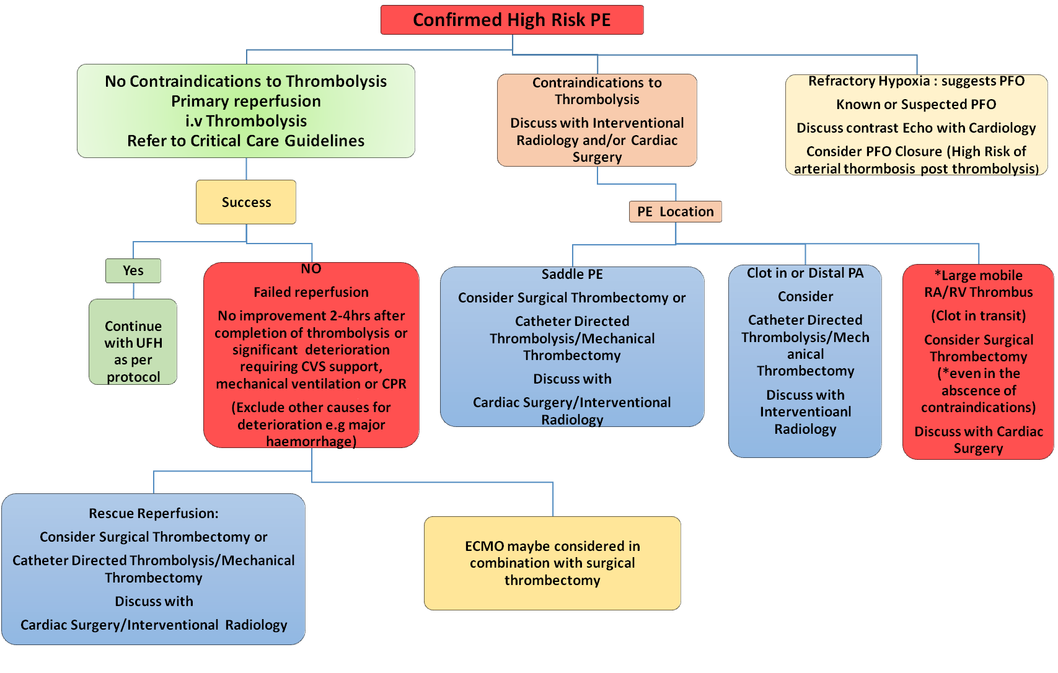

**Figure 2: Treatment Plan for High Risk PE**

1. **SYSTEMIC THROMBOLYSIS**

* Alteplase infusion: Prescribe alteplase infusion: 10mg of alteplase as IV bolus over 2 minutes, followed by 90mg as IV infusion over 2 hours, refer to relevant link:

[ALTEPLASE thrombolysis of massive pulmonary embolism (scot.nhs.uk)](http://intranet.lothian.scot.nhs.uk/Directory/CriticalCare/Critical%20Care%20Guidelines/Drugs%20and%20fluids/Alteplase%20for%20massive%20PE.pdf)

* Systemic thrombolysis is safe to give if LWMH has already been administered.
* Consider contra-indications to thrombolysis: see Table 3 below
* In massive PE, even in the presence of contra-indications, it may be that thrombolysis is still considered and given, due to the high risk of death.
* The greatest benefit is observed when treatment is initiated within 48h of symptom onset, but thrombolysis can still be useful in patients who have had symptoms for 6-16 days

A number of absolute and relative contraindications are listed below

|  |  |
| --- | --- |
| **Absolute Contraindications** | **Relative Contraindications** |
| Known hypersensitivity to the active substance, gentamicin (a trace element from the manufacturing process) or to any of the excipients. | Recent bleeding (non intracranial). |
| Active gastrointestinal/gastric ulcer bleeding or severe active bleeding from any site. | Recent major surgery (within 3 weeks). |
| Significant head or facial trauma or brain injury within past 3 months  Structural intracranial disease (i.e.neoplasms, aneurysm, AVM) | Traumatic cardiopulmonary resuscitation.  Recent invasive procedure (including non compressible vascular punctures) |
| Known history of ischaemic stroke or transient ischaemic attack in the preceding 6 months, except current acute ischaemic stroke within 4.5 hours  Known history of or suspected intracranial/subarachnoid haemorrhage or haemorrhagic stroke | Anticoagulation (including Vitamin K Antagonists). |
| Bleeding diathesis | Uncontrolled Hypertension, Age >75 |
| Suspected aortic dissection | Pregnancy or recent delivery |

**Table 3: Contra indications to Thrombolysis**

Please refer to the relevant link for more information

[ALTEPLASE thrombolysis of massive pulmonary embolism (scot.nhs.uk)](http://intranet.lothian.scot.nhs.uk/Directory/CriticalCare/Critical%20Care%20Guidelines/Drugs%20and%20fluids/Alteplase%20for%20massive%20PE.pdf)

If possible, **consent** that patient for thrombolysis

**Relative risks of bleeding**

|  |  |  |
| --- | --- | --- |
|  | **Thrombolysis + Anticoagulation** | **Anticoagulation alone** |
| Major Bleeding | ~10-15% | ~4% |
| Intracranial Haemorrhage | ~2% | ~0.2% |
| Death from all causes | ~2% | ~4% |

**Table 4 : Relative Risks of bleeding**

**Failed thrombolysis**

Defined as persistent clinical instability within 2-4 hrs post thrombolysis or significant deterioration requiring CVS support, mechanical ventilation etc.

**Refractory Hypoxaemia**

* Refractory Hypoxaemia in a patient with acute PE can be associated with a right to left cardiac shunt through a PFO
* If know(n) or suspected PFO discuss with cardiology re bubble contrast ECHO
* If no instability and a PFO is confirmed with right to left shunt at rest: Consider Doppler US of the legs: if clot in proximal veins i.e. residual iliofemoral DVT, discuss urgent closure of the PFO and/or IVC filter.

1. **EMBOLECTOMY**

Embolectomy is indicated in patients with hemodynamically unstable PE in whom thrombolytic therapy is contraindicated. It is also a therapeutic option in those who fail thrombolysis. Emboli can be removed surgically or using a catheter. The choice between these options depends upon available expertise, the presence or absence of a known diagnosis of PE, underlying comorbidities, and the anticipated response to such therapies

**Catheter Directed Therapies**

* **Catheter Directed thrombolysis (CDT)**

CDT should be considered when;

* Systemic thrombolysis has been unsuccessful
* High Risk and Intermediate-High Risk PE – where it is felt the bleeding risk outweighs the benefit of systemic thrombolysis

CDT uses a lower dose of thrombolysis and has a safer bleeding risk profile than systemic thrombolysis. However, it takes time to set-up and may not be available immediately.

This technique is organised through contacting Interventional Radiology. A pulmonary artery catheter is placed into the right and left Pulmonary artery and alteplase is infused at 10mg/24 hrs into each. If CDT is felt to be the most suitable therapy, but is not available at your site, site transfer should be considered.

* **Mechanical Thrombectomy (MT)**

MT should be considered when;

* Systemic thrombolysis has been unsuccessful
* High Risk and Intermediate-High Risk PE – where it is felt the bleeding risk outweighs the benefit of systemic thrombolysis

MT aims to remove embolic material from the pulmonary arteries. This is achieved using an aspiration system through large bore catheters. There are two main types of system with different advantages and disadvantages, selected based on the PE clot load and distribution. CDT catheters may also be left behind following MT**.**

These relatively novel systems often require additional staff, time and resources to support. Therefore, MT is currently only available in hours. Again, this technique is organised through contacting Interventional Radiology**.**

**Surgical Embolectomy**

Surgical embolectomy should be considered when:

-        Systemic thrombolysis has been unsuccessful or in

-         High Risk and Intermediate-High Risk PE – where it is felt the bleeding risk outweighs the

benefit of either full-dose or low-dose systemic thrombolysis

And there is a

-          Clot in the RA, RV, main PA or traversing a PFO to reduce the risk of rapid deterioration or stroke (in the case of a PFO).

Surgical embolectomy requires a careful MDT approach including ITU, anaesthetics, cardiothoracic surgery and haematology. Recent thrombolysis is not a contra-indication to potential surgery.

1. **SUPPORTIVE TREATMENT**

**Oxygen therapy and ventilation**

* Administration of supplemental oxygen is indicated in patients with PE and SaO2 <90%
* Correction of hypoxia will not be possible without simultaneous reperfusion
* High Flow Nasal Oxygen should be considered
* Intubation and mechanical ventilation should be considered in patients with extreme instability and patients unable to tolerate or cope with HFNO
* If mechanical ventilation is used, positive pressure may reduce venous return and worsen low CO, and should be applied with caution
* Severe hypoxaemia/respiratory failure that is refractory to conventional oxygen supplementation could be explained by right-to-left shunt through a patent foramen ovale or atrial septal defect

**Cardiovascular Support**

* Cautious volume loading: if low arterial pressure is combined with an absence of elevated filling pressures.
* Assessment of central venous pressure by ultrasound imaging of the IVC (a small and/or collapsible IVC in the setting of acute high-risk PE indicates low volume status) or, alternatively, by central venous pressure monitoring might guide volume loading. If signs of elevated central venous pressure are observed, further volume loading should be withheld.
* Use of vasopressors: In parallel with (or while waiting for) pharmacological, surgical, or interventional reperfusion treatment.
* Noradrenaline
* Dobutamine: may be considered for patients with PE, a low cardiac index, and normal BP; however, raising the cardiac index may aggravate V/Q mismatch by further redistributing flow from (partly) obstructed to unobstructed vessels
* Vasodilators decrease PAP and PVR, but may worsen hypotension and systemic hypoperfusion due to their lack of specificity for the pulmonary vasculature after systemic administration.

**Mechanical circulatory support (VA ECMO)**

Use of ECMO is associated with a high incidence of complications, even when used for short periods, and the results depend on the experience of the centre as well as patient selection. The increased risk of bleeding related to the need for vascular access should be considered, particularly in patients undergoing thrombolysis. At present, the use of ECMO as a stand-alone technique with anticoagulation is controversial and additional therapies, such as surgical embolectomy, have to be considered

Recent experience appears to support combining ECMO with surgical embolectomy, particularly in patients with high-risk PE with or without the need for cardiopulmonary resuscitation.

**TREATMENT PLAN FOR INTERMEDIATE HIGH RISK PE**

**Figure 2: Treatment Plan for Intermediate -High Risk PE**

## 

**KEY PRINCIPLES**

* Intermediate-High risk PE patients may present with significant symptoms and/or large volume clot on CTPA whilst not meeting high risk criteria. These patients may have a positive troponin (indicating myocardial damage), a high risk sPESI or evidence of RV dysfunction on imaging.
* Intermediate-high risk patients have a higher mortality than low-risk patients and can deteriorate rapidly, warranting consideration for higher level of monitoring over the first few hours or days. Risk of rapid deterioration is higher within the first 48hrs and need admission to a monitored area as appropriate.

* Primary reperfusion treatment is not routinely recommended, as the risk of potentially life-threatening bleeding complications appears too high for the expected benefits from this treatment

**Management**

* If hypotensive (SBP <90mmHg) refer to the High-risk PE guideline
* If at presentation patients appear critically unwell (e.g. marked hypoxaemia, high lactate, signs of right heart failure) but not meeting criteria for High Risk PE**,** reperfusion therapy can still be considered. **Discuss with MDT**
* If clinically deteriorating (e.g. progressive hypoxaemia, rising heart rate, high or rising lactate, clinical features of circulatory compromise e.g. cold, clammy, cyanosis), consider reperfusion therapy in any modality. **Discuss with MDT**

**REFERENCES**

1. 2019 ESC Guidelines for the diagnosis and management of acute pulmonary embolism developed in collaboration with the European Respiratory Society (ERS) The Task Force for the diagnosis and management of acute pulmonary embolism of the European Society of Cardiology (ESC)
2. Contemporary interventional management of pulmonary embolism A. Gupta a , N. Thulasidasana , S.M. Mak b , B. Rawal c , S.P.G. Padley c , N. Karunanithy Clinical Radiology 78 (2023) 315e32
3. Percutaneous treatment options for acute pulmonary embolism: a clinical consensus statement by the ESC Working Group on Pulmonary Circulation and Right Ventricular Function and the European Association of Percutaneous Cardiovascular EuroIntervention 2022;18: e623- e638 published online ahead of print September 2022